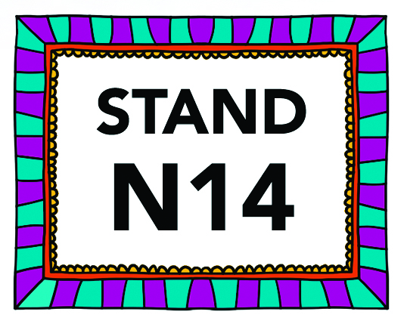

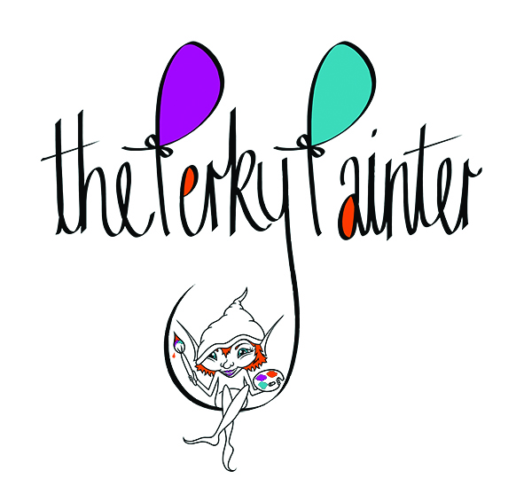
The Perky Painter Press Release April 2016 / For Immediate Release

Happy Art Debuts at the British Craft Trade Fair

The Perky Painter is the passion and heart of Artist Helen Gibson. Helen crafts vibrant acrylic and digital paintings alive with character. The goal: to bring joy to the viewer.

“Creating smiles feels even better than creating the artwork!“

Helen’s story begins not as happy, enduring chronic pain and trying countless medications. Helen’s love of painting pulled her through, she created strange and personal artwork from her own medical investigation photographs.
(Reference image: Lame/2008/Oil on Canvas)

Helen then turned her attention to reclaiming happiness, creating bright, colourful art with eccentricity. The Perky Painter was born.

“Painting got me through a bad time, after that I decided I was going to make my own happiness, for myself and for others so I set about on my happy art journey!”

Helen has spent the last few years creating vivid, spirited paintings in preparation for her artistic debut.

Helen began experimenting with digital painting and, what she likes to call, “Math Art” – the visual equation of adding two ideas. Helen’s bold digital paintings are shaped through the alteration of a simplified animal form by combining with a familiar theme to become humorous characters. Themed families include the fruit-animals, or “Fruinimals”, the bow-animals, “Bowimals” and Christmas-animals. Helen is currently working on the Flowermals (flower-animals) and the Mechanimals (machine-animals).
At the British Craft Trade Fair, 10th – 12th April, Helen is unveiling her exciting new range of goods made from her acrylic and digital paintings from mugs to tote bags.

At the British Craft Trade Fair, 10th – 12th April, Helen is unveiling her exciting new range of goods made from her acrylic and digital paintings from mugs to tote bags.

“I want people without either the means, need or desire for on the wall paintings to be able to access my art”

After The Perky Painter’s debut at BCTF, Helen has an exciting year ahead being chosen to exhibit at ‘Art in the Pen’, which takes place in Carisle, Thirsk and Skipton this summer.

Helen has also been selected for Horsforth Walk of Art where she is working with a pre-school hoping to inspire the next generation of perky painters.

The Perky Painter can also be found regularly in her hometown at Leeds Corn Exchange’s Unique Gift Fair.

ends

Contact Information:
Helen Gibson
Helen@thePerkyPainter.com
Telephone: 07805-337-104
Website: www.thePerkyPainter.com
Social Media (Facebook/Twitter/Instagram/Pinterest) @thePerkyPainter

Stand N14

